# Introduction

## A general introduction to the game

Dread of the Evil Wizard is a text based RPG where the main character’s sister is a captive of the Evil Wizard and must be rescued. The game is single player and turn based so after every move user makes game decides a move and responds to the player. This automated responses are displayed on the console and user must enter the commands to the command interface. Results of both player’s and computer’s actions are displayed on the map. Screenshots of these components are provided in the Playing Game section to better explain.

# Installation

## System requirements

* No constraint on OS but a recent version of Java Runtime environment must be installed.
* 1 GB of memory.
* A minimum of 1280x720 resolution.

## Installation steps

No complicated installation steps are needed. In a system fulfilling the above requirements can execute the game by simply double clicking the Dotew.jar

# Playing the game

## Startup

Startup screen presents use the options about the game which are a new game, load an existing game, settings(background music etc.), credits which displays the info about the developer team and final option is exit.

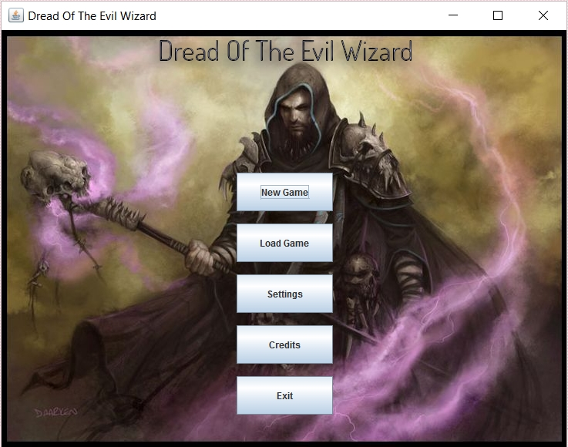

## New Game

Upon selecting a new game session player must select which class the character is going to be specifics of the classes are discussed below in the abilities of classes and monsters section.

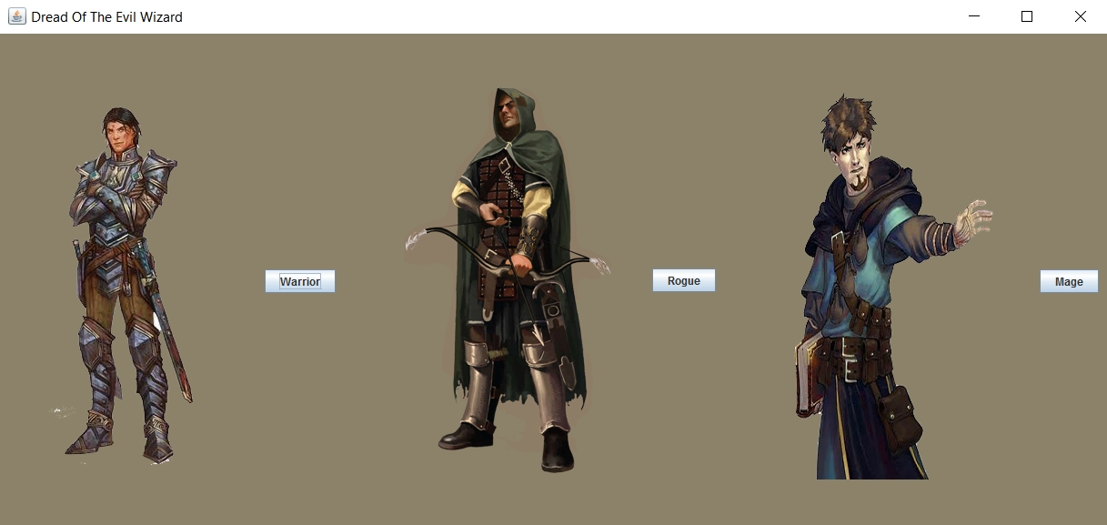

After selecting one of the three classes adventure starts with the actual game screen.

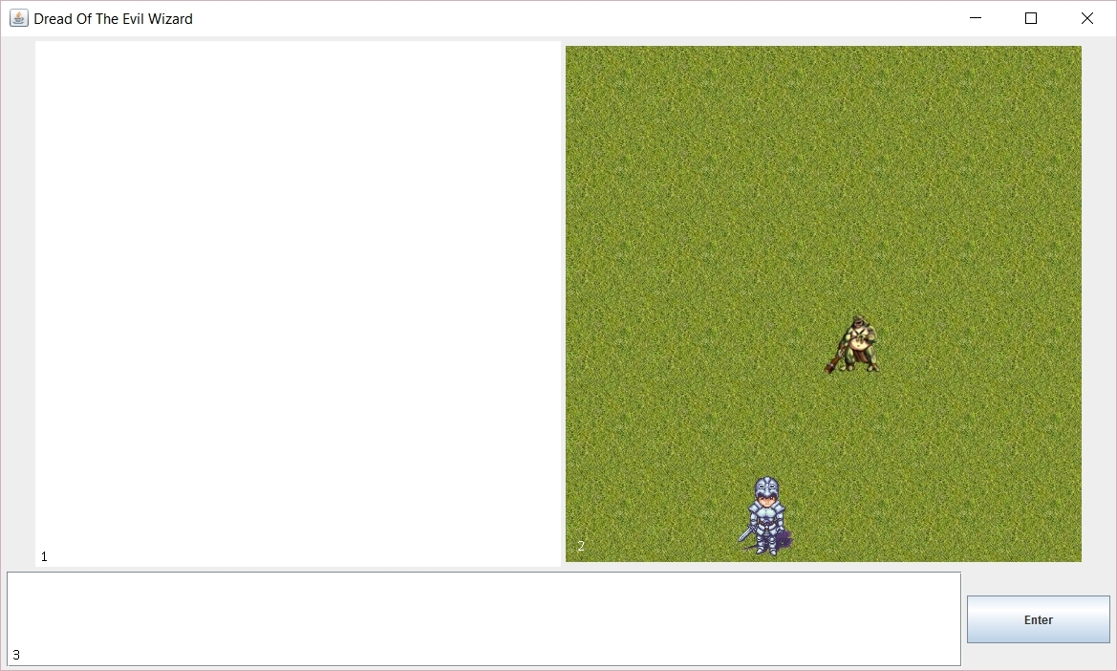

### Responder

Responder displays the text about the events in the game for example success of an attack and how many points of damage is caused to the opponent or when player moves in the map what player sees is described here according to the information given to the player here after computer’s turn player must use the input section to make his/her own move.

### Map

Map provides the general information of the whereabouts of the player this is helpful for the player because player can see the boundaries of the map and how the terrain on the map is going to be detailed specifics of that portion of the map are given in the responder with a detailed description upon entering that region.

### Input

The interactions of the character must be entered here there are predefined commands and game accepts only these commands. Commands are case insensitive meaning “move north” and “mOvE nOrTh” are treated the same but “go up” and “go to evil wizard” are not accepted because they are not predefined commands. Predefined commands includes commands such as go <direction>, attack, block etc.

## Battle

Battles have their own viewings and this viewings are displayed in the map portion of the game screen. When a battle is started the battle map is displayed in the map portion of the screen instead of the regular roaming map and these two different maps have different mechanisms. For the full duration of the battle the battle map is displayed in the map area and replaced with the regular map after one of the combatants is defeated.

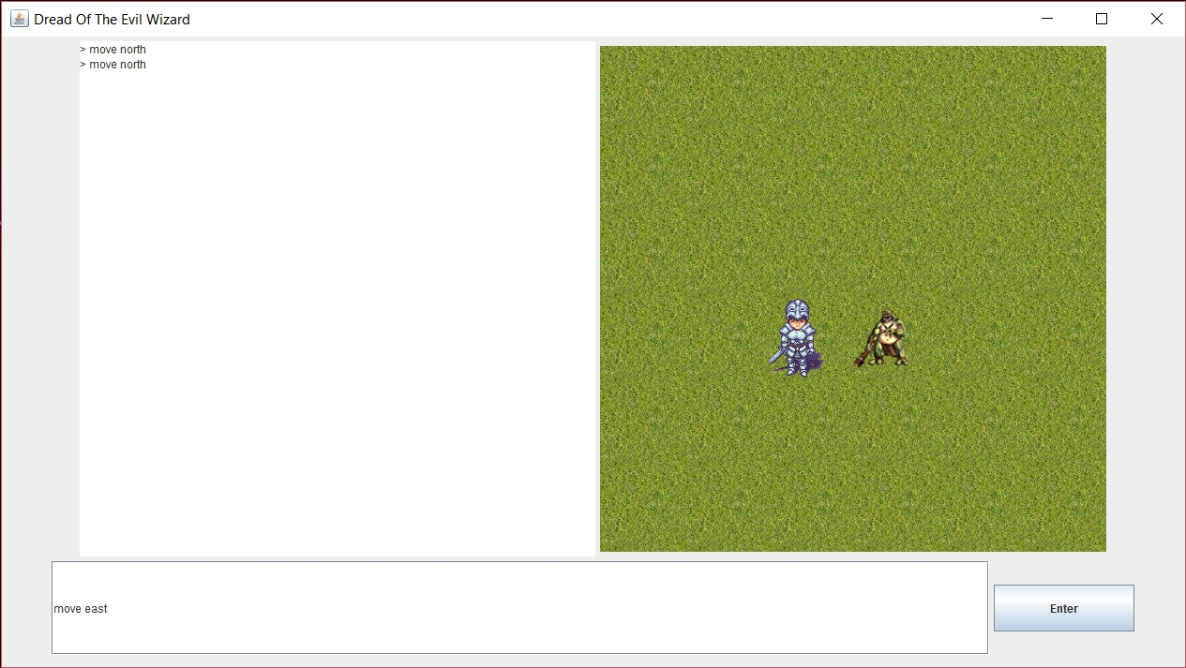

Approaching the opponent and using the command to enter the same region within the opponent player must type move east at this point and battle starts with battle screen

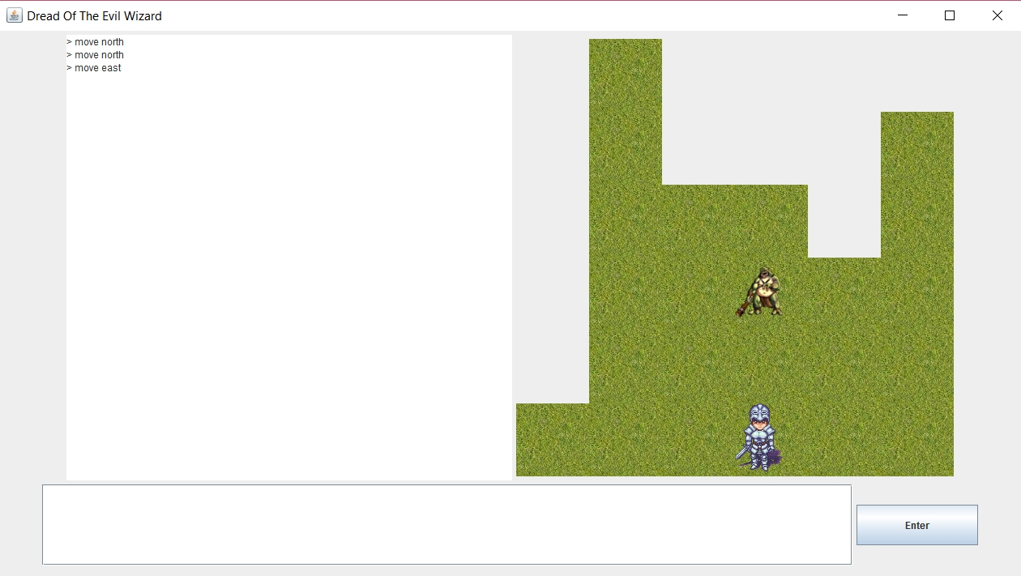

## Credits

Credits option displays the information about the developer team.

## Exit

Exits the game and closes the window.

# Abilities of Classes and Monsters

## Monsters

Except the Evil Wizard there are three types of monsters which a player may going to slay.

### Human

These poor humans have their minds warped by the Wizard and serve to his evilness to the death. They can be any one of three classes which player also is one of the three discussed below.

### Ghoul

Some ghouls are regular and some are poisonous they are undead and resurrected by the evil wizard they attack any living creature they encounter and try to eat their flesh.

### Ogre

Ogres are giant less intelligent creatures but their appetite for human meals is unprecedented. Some may try to mash the opponent with their club, some try to cook with their fire breath and some can freeze the opponent best to be avoided.

## Classes

### Warrior

A strong melee fighter that charges head first into enemy lines. Has strong physical attacks and high health points and uses stamina.

**Skills:**

* Chargee!! : Directly run towards the enemy and attack it with your whole body and momentum. Deals damage and stuns the enemy for 1 turn.
* Ravage: Attacks the enemy 3 consecutive times. Deals massive damage.
* Block: Blocks an incoming enemy attack.(Cannot attack the next turn)
* Berserker’s blood: Warrior gives into his rage and goes berserk for 5 turns. Increases base strength and dexterity stats.

### Rogue

Cunning and fast, rogues uses their wits and clever tactics to defeat their enemies. Has high dexterity and uses stamina.

**Skills:**

* Backstab: Run to the back of an enemy and backstab it. Deals big damage.
* Poison knife: Coat your weapon with poison. Attacks deal poison damage.
* Knife throw: Throws a knife at enemy far away. Deals damage.
* Invisibility: Turn invisibly for 3 turns. Enemies cannot attack you, you can move freely.

### Mage

Uses magic and elemental spells to defeat enemies. Low health points, high mana, very high damage potential.

**Skills:**

* Fireball: Throw a fireball at an enemy. Deals great damage and burns the enemy.
* Ice spike: Creates and ice spike in air and throws it to the enemy. Deals damage and freezes enemy.
* Deflect: Use magical powers to reflect an incoming attack.(cannot attack in the next turn)
* Cosmic light: If this is used on an enemy, it deals massive damage. If used on self, character heals back to full hp.